Introduction:
Before beginning to draft your RFP, you should adequately screen your proposed site using the provided screening survey. If you represent a State agency, you can request assistance from the Office of Enterprise Sustainability with a pre-engineering feasibility analysis.
The objective of this document is to enumerate and describe pertinent exhibits to include for an site specific RFP against the State’s on-site solar PV master contract (S-1049(5)). While not exhaustive, this list can inform agencies of the due diligence needed for different types of solar PV solicitations. The focus is not RFP specifications, terms, and conditions, but site-specific data that the soliciting entity should include in their solicitation.
Definition of “Site:”
In general, the specific “bids” should be separated by “site.” In general, the site is defined as one contiguous piece of property owned by the soliciting entity that will host the solar installation. The site could have one electric meter, it could have several, could be one building or a collection of several. The critical criterion is that the site falls under the State’s net metering rules. Minnesota law allows customers to aggregate the consumption of multiple meters and apply the electricity produced by their solar PV system to those meters in the order they choose; however, the meters must be on contiguous property owned by the same customer. Some utilities also require the meters to be either all Time-of-Day rates or not Time-of-Day rates. (Minn. Stat. 216B.164; Subd. 4a). For a simple explanation of Minnesota’s net metering rules, take a look at this Dept. Of Commerce page.
Here is the most basic diagram of how a net metering system technically works:
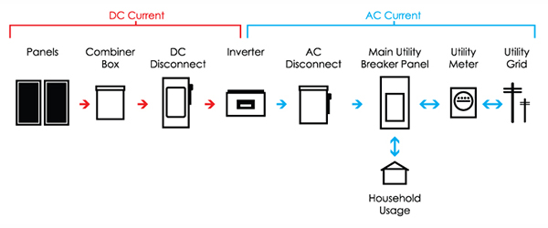
The net metering rules differ somewhat for systems under 40 kW DC, systems over 40 kW DC and under 1 MW DC. Refer to the linked Commerce page for more info.
- General Information Needed:

Site: [Short name of the site]
- Address: [enter full address of the site]
- Total square footage of contiguous, unobstructed area available: [measure using paces or Google Earth the total surface area of the proposed installation location. The simplest and best performing systems are simple arrays arranged with modules of the same orientation and tilt which are wired in series. You want to identify a rectilinear space with minimal to no shading and minimal to no obstructions (obstructions being vents, HVAC equipment, lighting protection etc..)].
    - To be worthwhile, a rooftop installation is going to need at minimum 2,500 to 3,000 square feet. A rule of thumb could be about 16 watts DC electrical capacity per square foot.
    - Make sure there is ample access to rooftop units and other equipment. OSHA requires that employees be 15 feet from roof perimeters if there is no fall protection.
- Distance to electrical service panel: [feet from the proposed install location to the point of interconnection (main utility breaker panel in the diagram) The AC disconnect is usually installed right next to your breaker panel. You will need to transport this AC current from the grid-tied inverter to the load using appropriate conductors. The objective of this datapoint is to measure how far and difficult it may be to run these electrical conducting wires from the inverter to the load.]
    - If a rooftop, look for vertical risers and areas that can easily have conduit routed through. Ideally, you can find a conduit pipe that has enough room to carry the solar energized conductors down to the main service panel.
    - If a ground mount, you’ll want to minimize the distance as much as possible. Avoid trees (roots) and concrete as these are costly to bore and trench through.
- Type of installation: [Ground mount, flat rooftop, pitched roof, carport, solar + storage]
- Number of service meters on-site: [this is just to help the developer understand the electrical landscape].
- Incoming voltage: [This is the incoming voltage from the step-down transformer, which brings in current from the distribution network and lowers the voltage to an appropriate level for a commercial/residential building]
- Basic assessment of shading: [use the Minnesota Solar Resource Tool to assess potential shading issues. You can do a site assessment of shading as well using off the shelf tools]
    - Look for a location with around 80% or higher unshaded resource.
- Requested capacity: [If you have a good idea of the general size, you can specifically request a range of solar capacity in watts DC or AC. If you are a State agency, OES can assist you with determining an adequate and financially optimal sizing.]
- Setbacks. Setbacks – the distance from the perimeter of an array or subarray to the roof parapet or roof edge. In a ground mount, the setback can pertain to the distance between the array and fencing. If you have important equipment on the rooftop that must be serviced routinely, you must ensure there is clearance for employees to safely reach the equipment (i.e., a route through the array etc..). Please refer to OSHA standards in the Code of Federal Regulations.
    - Without fall protection, if employees are regularly visiting the rooftop, the setback will have to be more than 15 feet.
    - While the master contract enforces that all laws be upheld, it is the soliciting entity’s responsibility to ensure that their project does not violate OSHA code.
    - After reviewing your rooftop operations and OSHA, it is highly recommended that you state a minimal setback distance.
- Copies of electricity bills
  - 12 months of electricity bills. Ideally, you should provide scans of one contiguous year of electricity bills. These scans are important because they inform the developer of a) your correct electricity rate, b) regulatory constraints such as pre-existing solar garden subscriptions and firm peak demand limitations (if you are on a peak control rate), and c) the annual kWh consumption for right-sizing the system. Scans are the best and are better than a spreadsheet report provided by your utility.
- Site plan:
  - Plan illustrating location of intended solar PV and location of main electrical service panel. This basic site plan can help the developer know what to expect when arriving on site. You can create this kind of plan using Google Maps and drawing tools from Microsoft Power Point. This does not have to be an engineering quality plan.
  - A site plan should be included for all types of installations.
  - A site plan should indicate staging locations.
  - Example of a basic site plan:
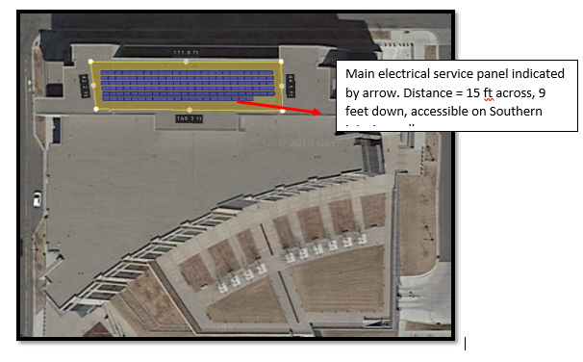

- Ground-Mount Installation Items:
  - Zoning requirements. The local planning and zoning authority can have an immense amount of power over what is and isn’t installed. Make certain that a ground mount solar installation can be installed on your property. Start with the city and its zoning ordinances. If it is near a city road, there may be stormwater runoff concerns and city engineering will need to be consulted. If it is near a county road, you will likely need to consult with the county.
  - Soil borings. Soil borings greatly improve the accuracy of bids because they inform the developer of the appropriate piles/structural foundations to secure and ground the solar installation to the earth. Because these can have considerable labor and material cost implications, having the soil information beforehand can greatly help to refine bids and avoid change orders.
    - 10 to 12 feet depth is adequate for detailing the soil composition
    - Request laboratory tests for: soil corrosivity and ampacity/resistance.
    - HERE is an example of a soil boring report.
  - Archaeological/Cultural impact assessment. You may want to consider an assessment of cultural resources or archaeological resources depending on your entity or the historical context of the install location.
  - Stormwater Runoff Mitigation (especially for installations affecting at least 1 acre)
    - All construction projects disturbing one or more acres of land must apply for the NPDES stormwater permit for construction activities, issued by the Minnesota Pollution Control Agency. More information HERE.
  - Plantings, grounds maintenance specifications
    - You should specify the type of plantings you would like to grow under the array. DNR’s PV pollinator friendly recommendations are the default per the master contract.
    - If you have specific considerations (I.e., should be able to fit a mower of X size between rows) you should specify that.
  - Map of utilities
    - If possible, OES would advise submitting a map indicating the locations of utility services (buried electrical conduit, buried plumbing etc..).

- Rooftop Installation Items:
  - Rooftop data:
    - Type of rooftop: PVC, EPDM, ballasted built up roof? These details inform the type of racking and ballasting as well as the installation process (I.e., if cap sheets need to be placed under the ballasted array etc..).
    - What is the type of rooftop deck?
    - Age of the rooftop [in years].
      - This is more a critical screening question. You should NOT consider a rooftop that needs replacement within 12 years or so. Ideally, the rooftop should be new – installed within the last 5 years.
    - Copy of rooftop warranty. The contractor is responsible for ensuring that the rooftop warranty is preserved (including costs, communication etc..). The roofing company will often need to be present when rooftop borings are conducted.
    - Cross sectional diagram of rooftop if available. HERE is an example.
  - Structural roof data:
    - How is the roof supported? Steel joists? Wooden trusses? Etc.. Pictures or diagrams would be good to include.
  - Roof structural analysis (OPTIONAL)
    - Most developers subcontract a structural engineer to review and stamp their projects. If you are dead set on installing PV at a rooftop X, you can save time by going ahead and having your own structural engineer conduct an assessment. Most agencies prefer ballasted installations because these have no rooftop penetrations. With a rough estimate of the systems’ size, you can estimate the structural loadings.
    - You can opt to perform the structural analysis through your contracting. The quoted price must include the cost of structural engineering as a “post contract award service”, per the master contract unless you perform it and explicitly state otherwise.

- Bids for a not-yet-built building
  - If your site is still in the engineering phase, it is essential that you ensure the following items are addressed:
    - Expected electricity consumption. To complete the interconnection application and adequately size your installation, developers will need to have a good estimate of what your electricity consumption is. Make sure that you have an energy model done for your building. If you have no energy model, or a adding a model is cost prohibitive, we recommend waiting 12 months after the building is operational as to have real-world data.
    - Structural assessment. Be sure to consult the engineering team very early on. You do not want to write an RFP for a building that is not designed to handle a PV system’s structural loads. If you are interested in installing PV on top of or near your to-be-built building, we recommend addressing the question as soon as possible in the design and engineering phases.

- Site Specific Construction Specifications, Terms or Conditions
  - Many agencies have specific construction practices that they adhere to with any construction project. Feel free to attach these items as exhibits to your RFP. It’s best practice to give developers a heads up for overhead/oversight or additional processes that may be required as a part of the final contract.
  - These specifications should be cited in the Specifications section, but can be attached as an Exhibit.
  - Examples might be time of work (6:00 AM to 6:00 PM etc...), manuals detailing all scheduled work for the construction from start to finish, conduct of contractors (clean up messes etc..., no swearing around public visitors, no spitting off rooftops etc..).

- No work before contract execution.
  - We must stress that under State of Minnesota law, no entity can request work before contracts are executed and notice to proceed is issued.
  - This is particularly problematic with applications like interconnection agreements and incentive programs.
  - Your entity could face significant issues if you violate these rules.
  - You are not liable for the vendors’ costs in preparing their response to your RFP. However, you must not request that work be completed before a contract is executed. During the evaluation, you absolutely cannot request that vendor complete an incentive application, interconnection agreement paperwork, or any other work until you have fully executed work order contracts and issued the vendor a “notice to proceed” with work.

